VISVESVARAYA TECHNOLOGICAL UNIVERSITY

“JnanaSangama”, Belgaum -590014, Karnataka.

LAB RECORD

Bio Inspired Systems (23CS5BSBIS)
Submitted by
SHASHANK SHANTHARAM NAYAK (1BM23CS313)
in partial fulfillment for the award of the degree of

BACHELOR OF ENGINEERING
in
COMPUTER SCIENCE AND ENGINEERING



B.M.S. COLLEGE OF ENGINEERING
(Autonomous Institution under VTU)
BENGALURU-560019
Aug-2025 to Jan-2026

B.M.S. College of Engineering,
Bull Temple Road, Bangalore 560019
(Affiliated To Visvesvaraya Technological University, Belgaum)
Department of Computer Science and Engineering

CERTIFICATE
This is to certify that the Lab work entitled “ Bio Inspired Systems (23CS5BSBIS)” carried out by SHASHANK SHANTHARAM NAYAK (1BM23CS313), who is bonafide student of B.M.S. College of Engineering. It is in partial fulfillment for the award of Bachelor of Engineering in Computer Science and Engineering of the Visvesvaraya Technological University, Belgaum. The Lab report has been approved as it satisfies the academic requirements of the above mentioned subject and the work prescribed for the said degree.

Rohith Vaidya K  Assistant Professor  Department of CSE, BMSCE | Dr. Kavitha Sooda  Professor & HOD  Department of CSE, BMSCE

Index
Sl.  No. | Date | Experiment Title | Page No.
1 | 29/8/25 | Gene Algorithm | 4
2 | 12/9/25 | Particle Swarm Optimization | 12
3 | 10/10/25 | Ant Colony Optimization | 17
4 | 17/10/25 | Cuckoo Search | 22
5 | 17/10/25 | Grey Wolf Optimizer | 26
6 | 07/11/25 | Parallel Cell Automaton | 31
7 | 29/8/25 | Gene Expression Algorithm | 35

Github Link:
https://github.com/DevelSSN/1BM23CS313-SHASHANK-SHANTHARAM-NAYAK/tree/BIS

Program 1
Gene Algorithm
Design and implement a simple genetic algorithm (GA) to iteratively evolve a population of candidate solutions (chromosomes) toward minimizing a given mathematical fitness function f(x)=x².

Algorithm:
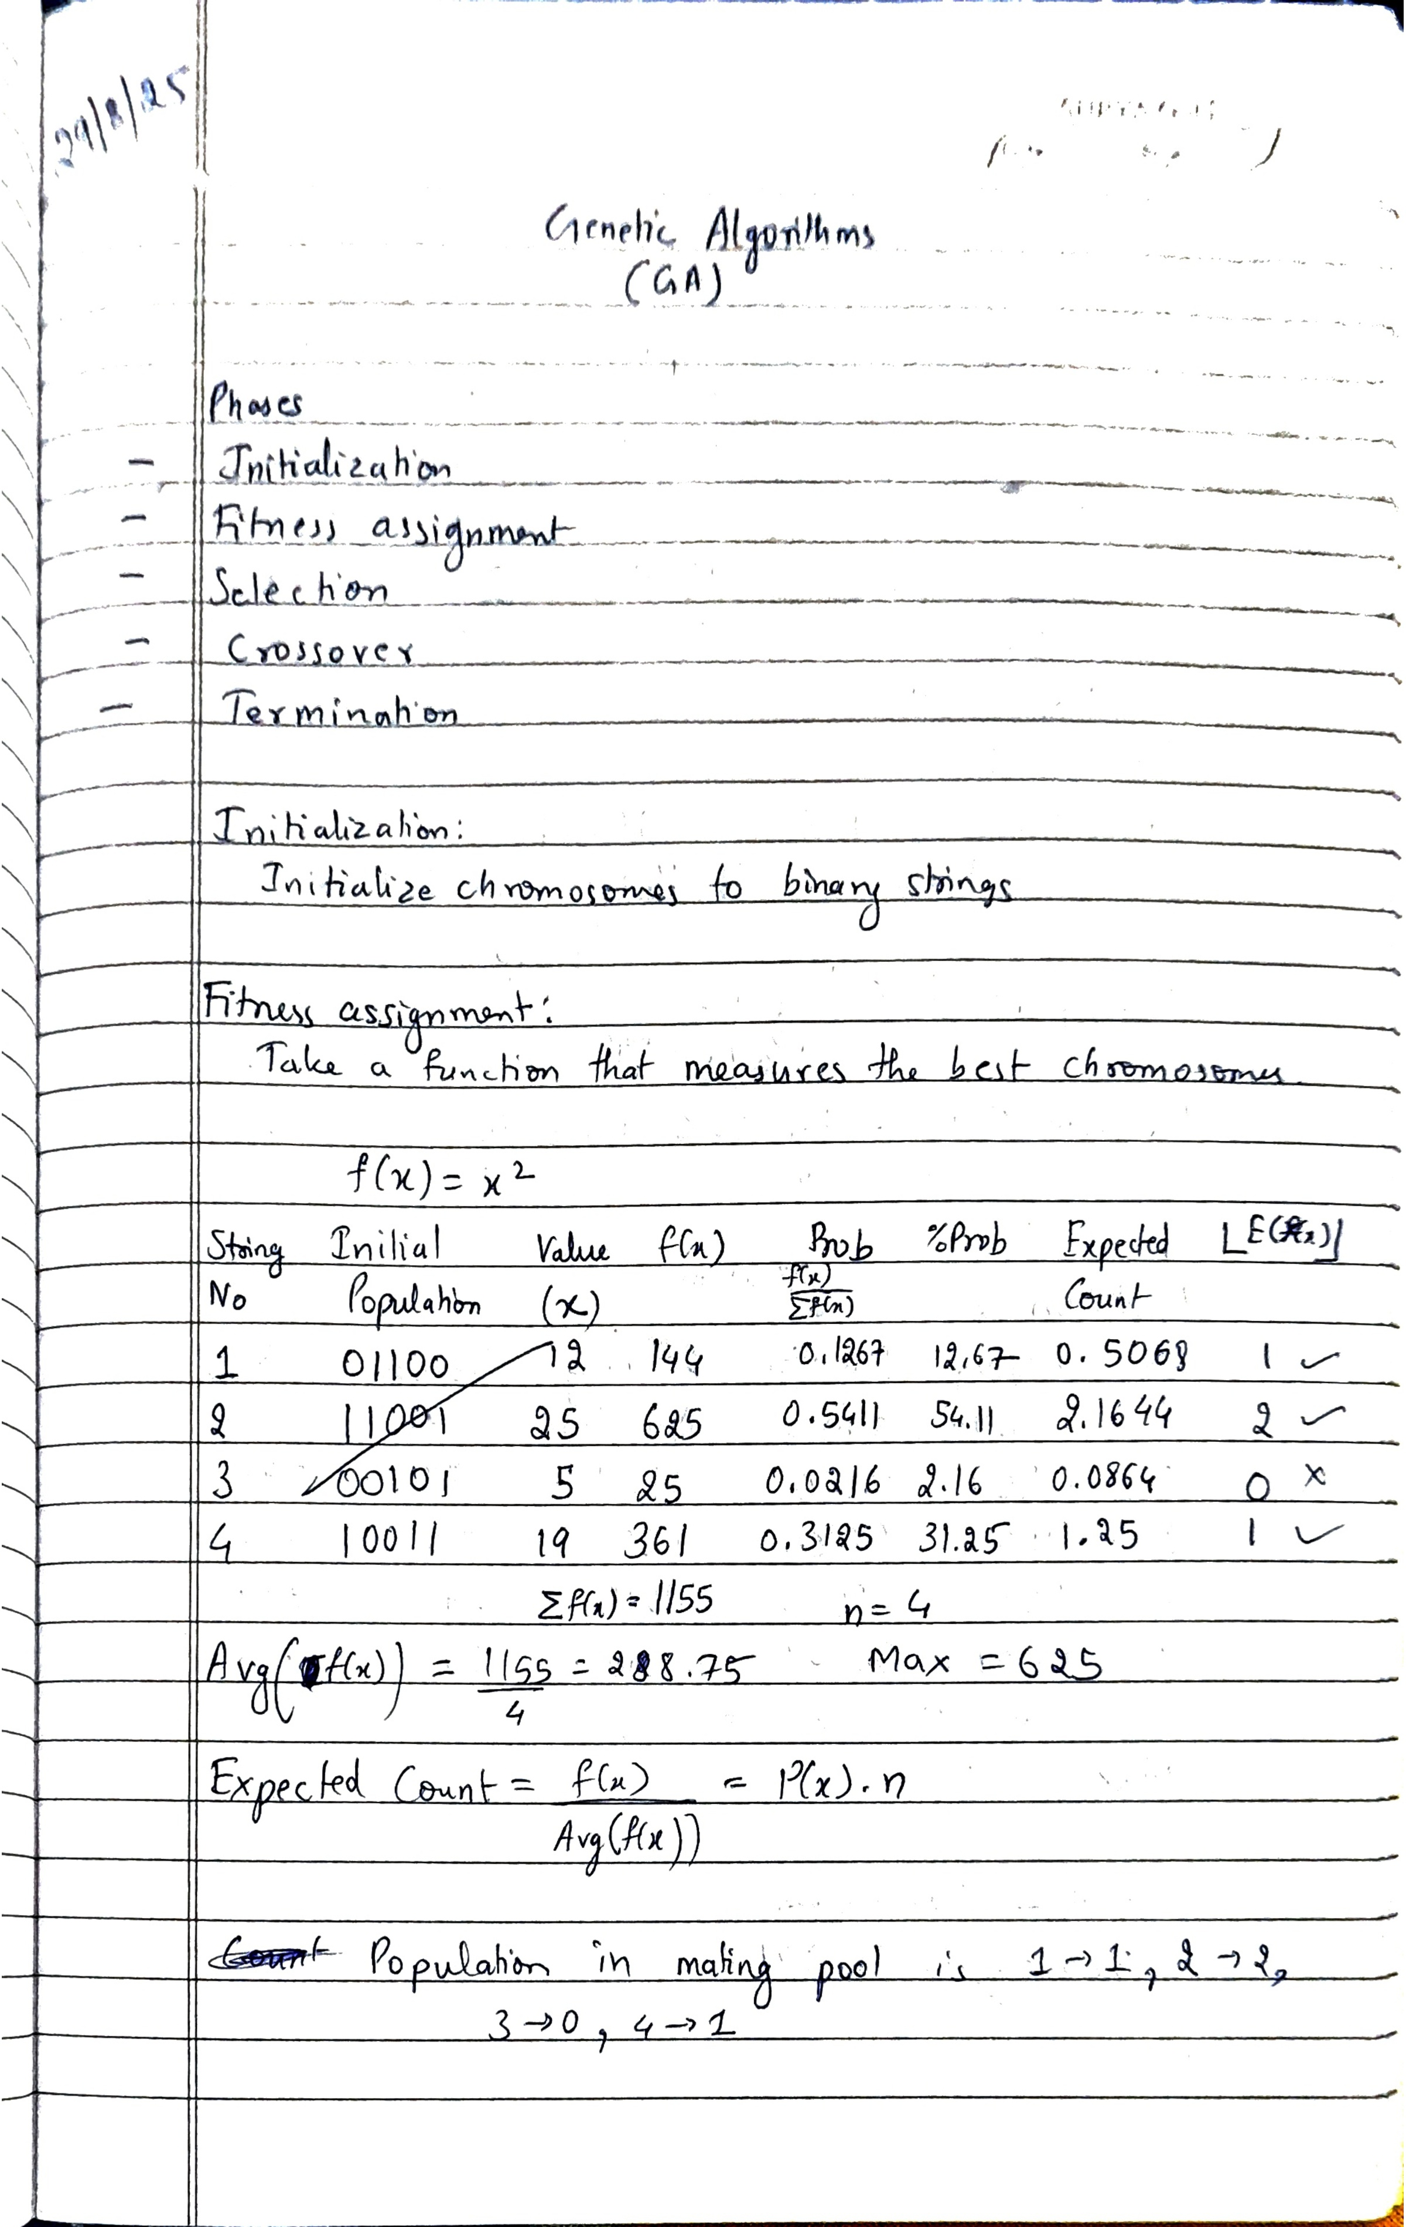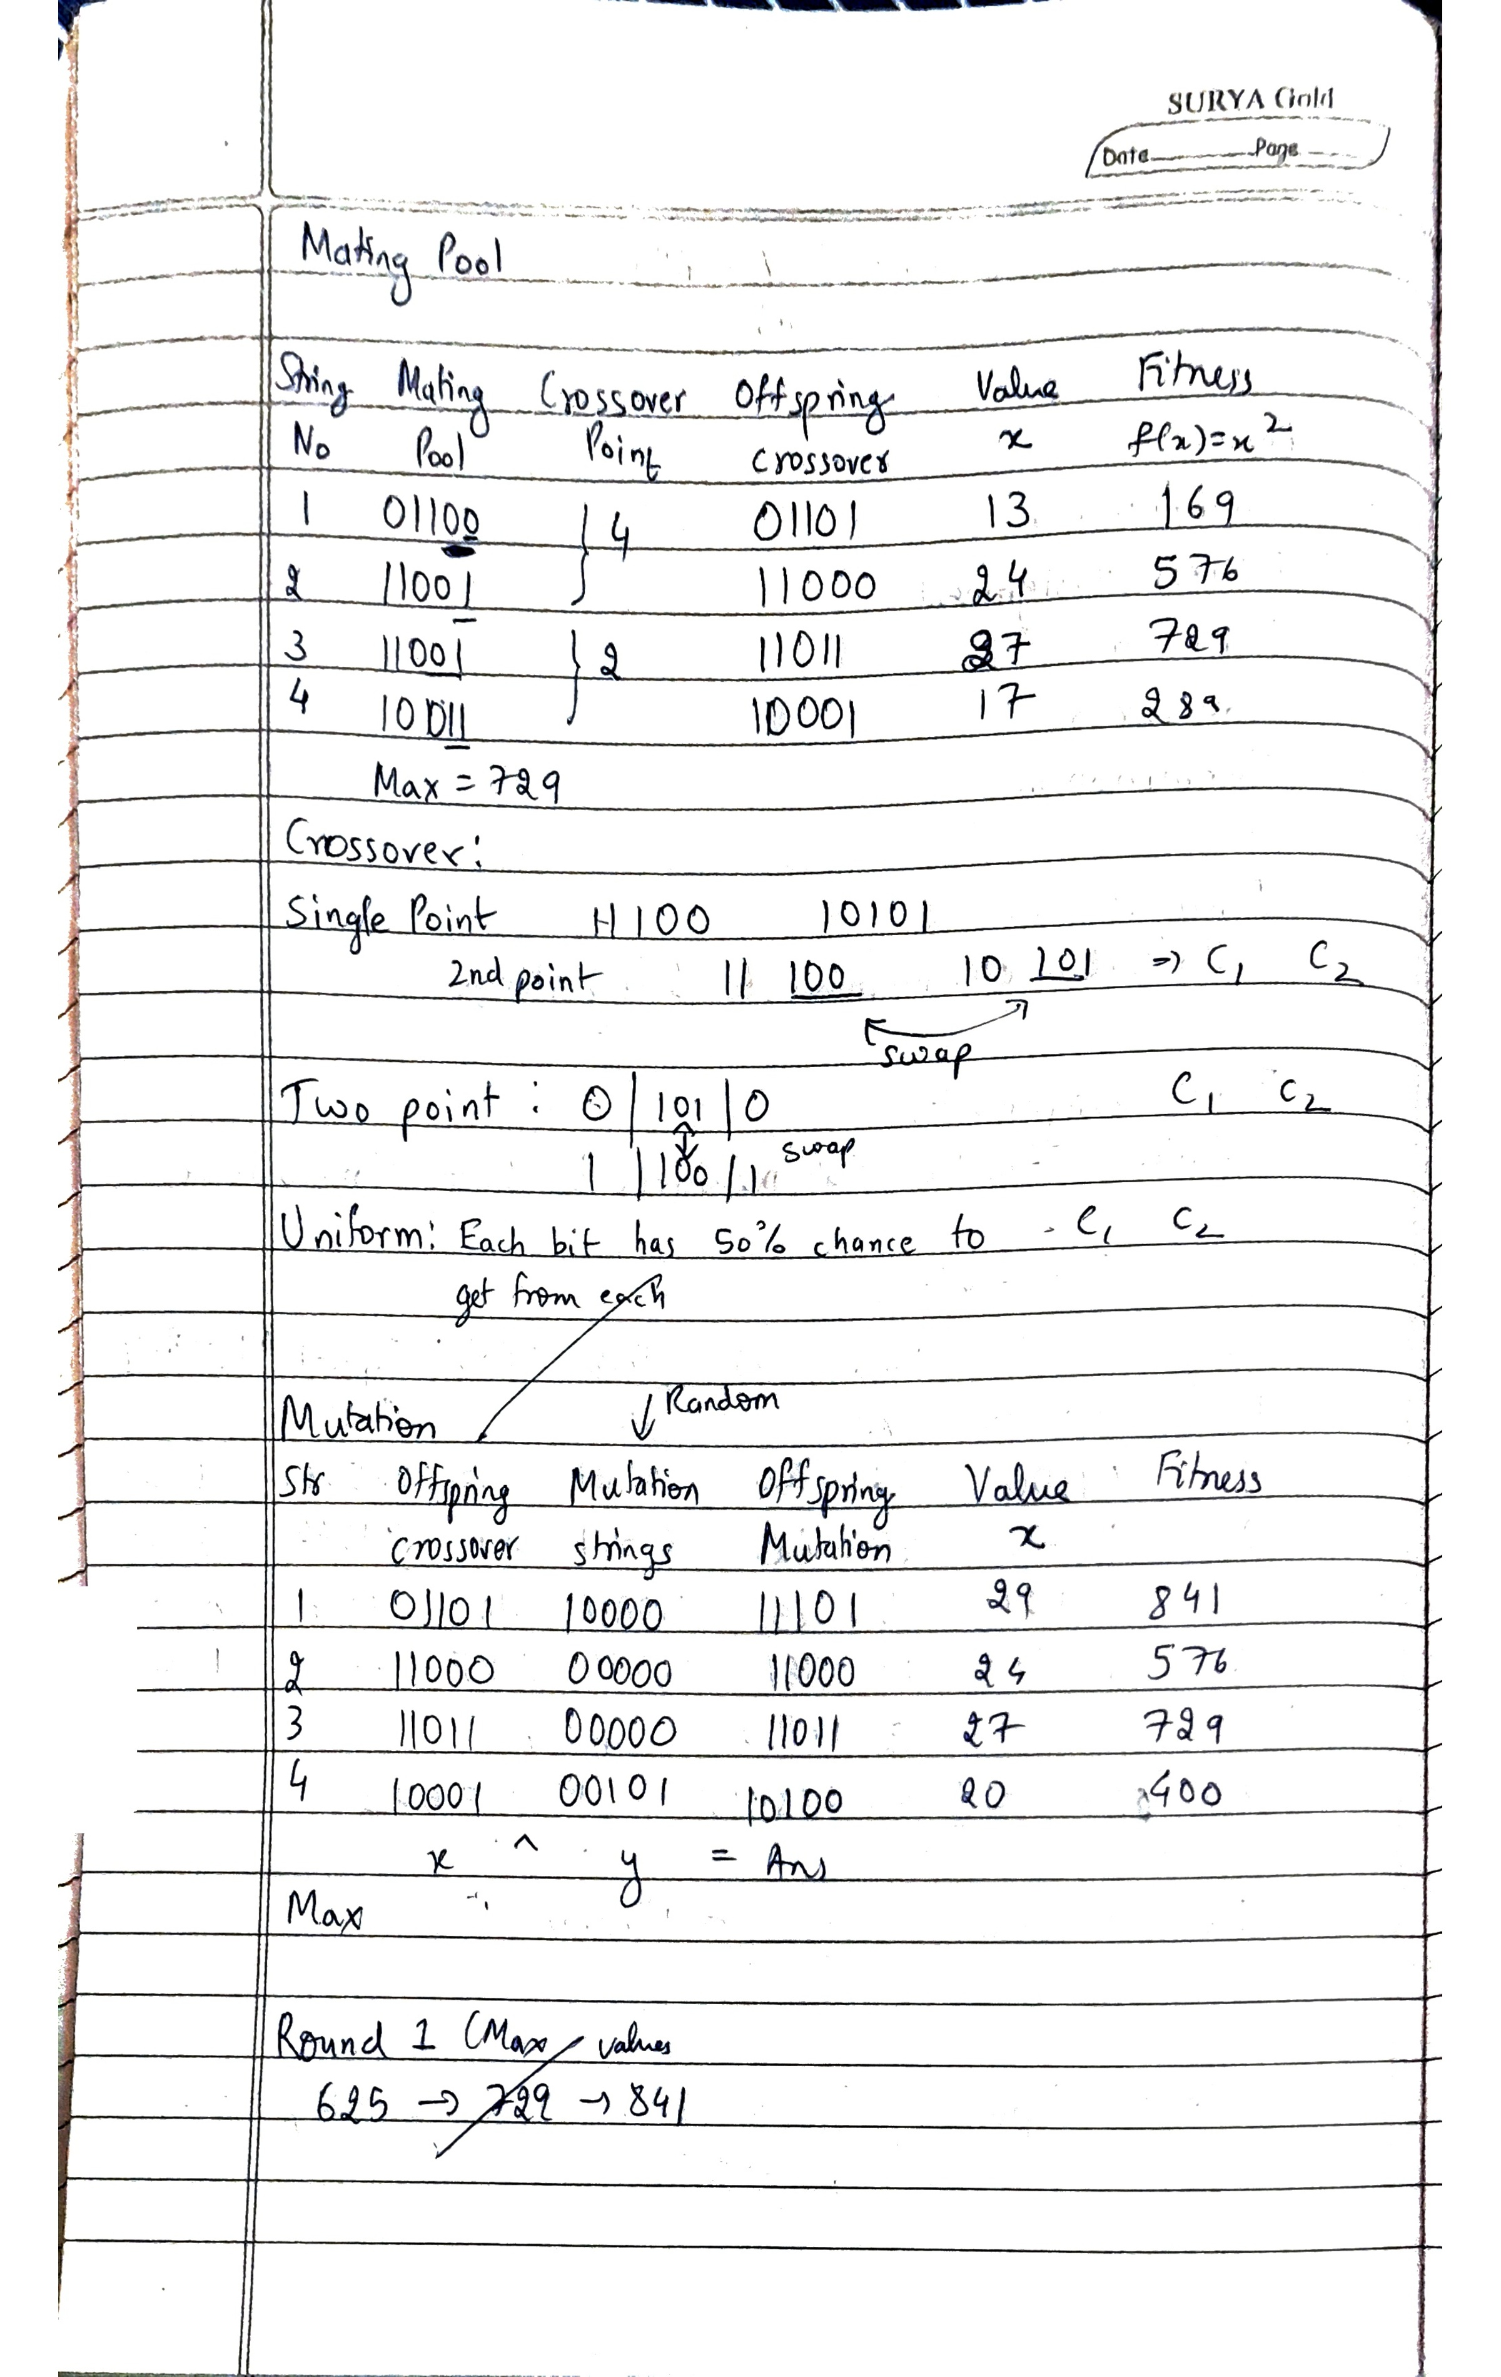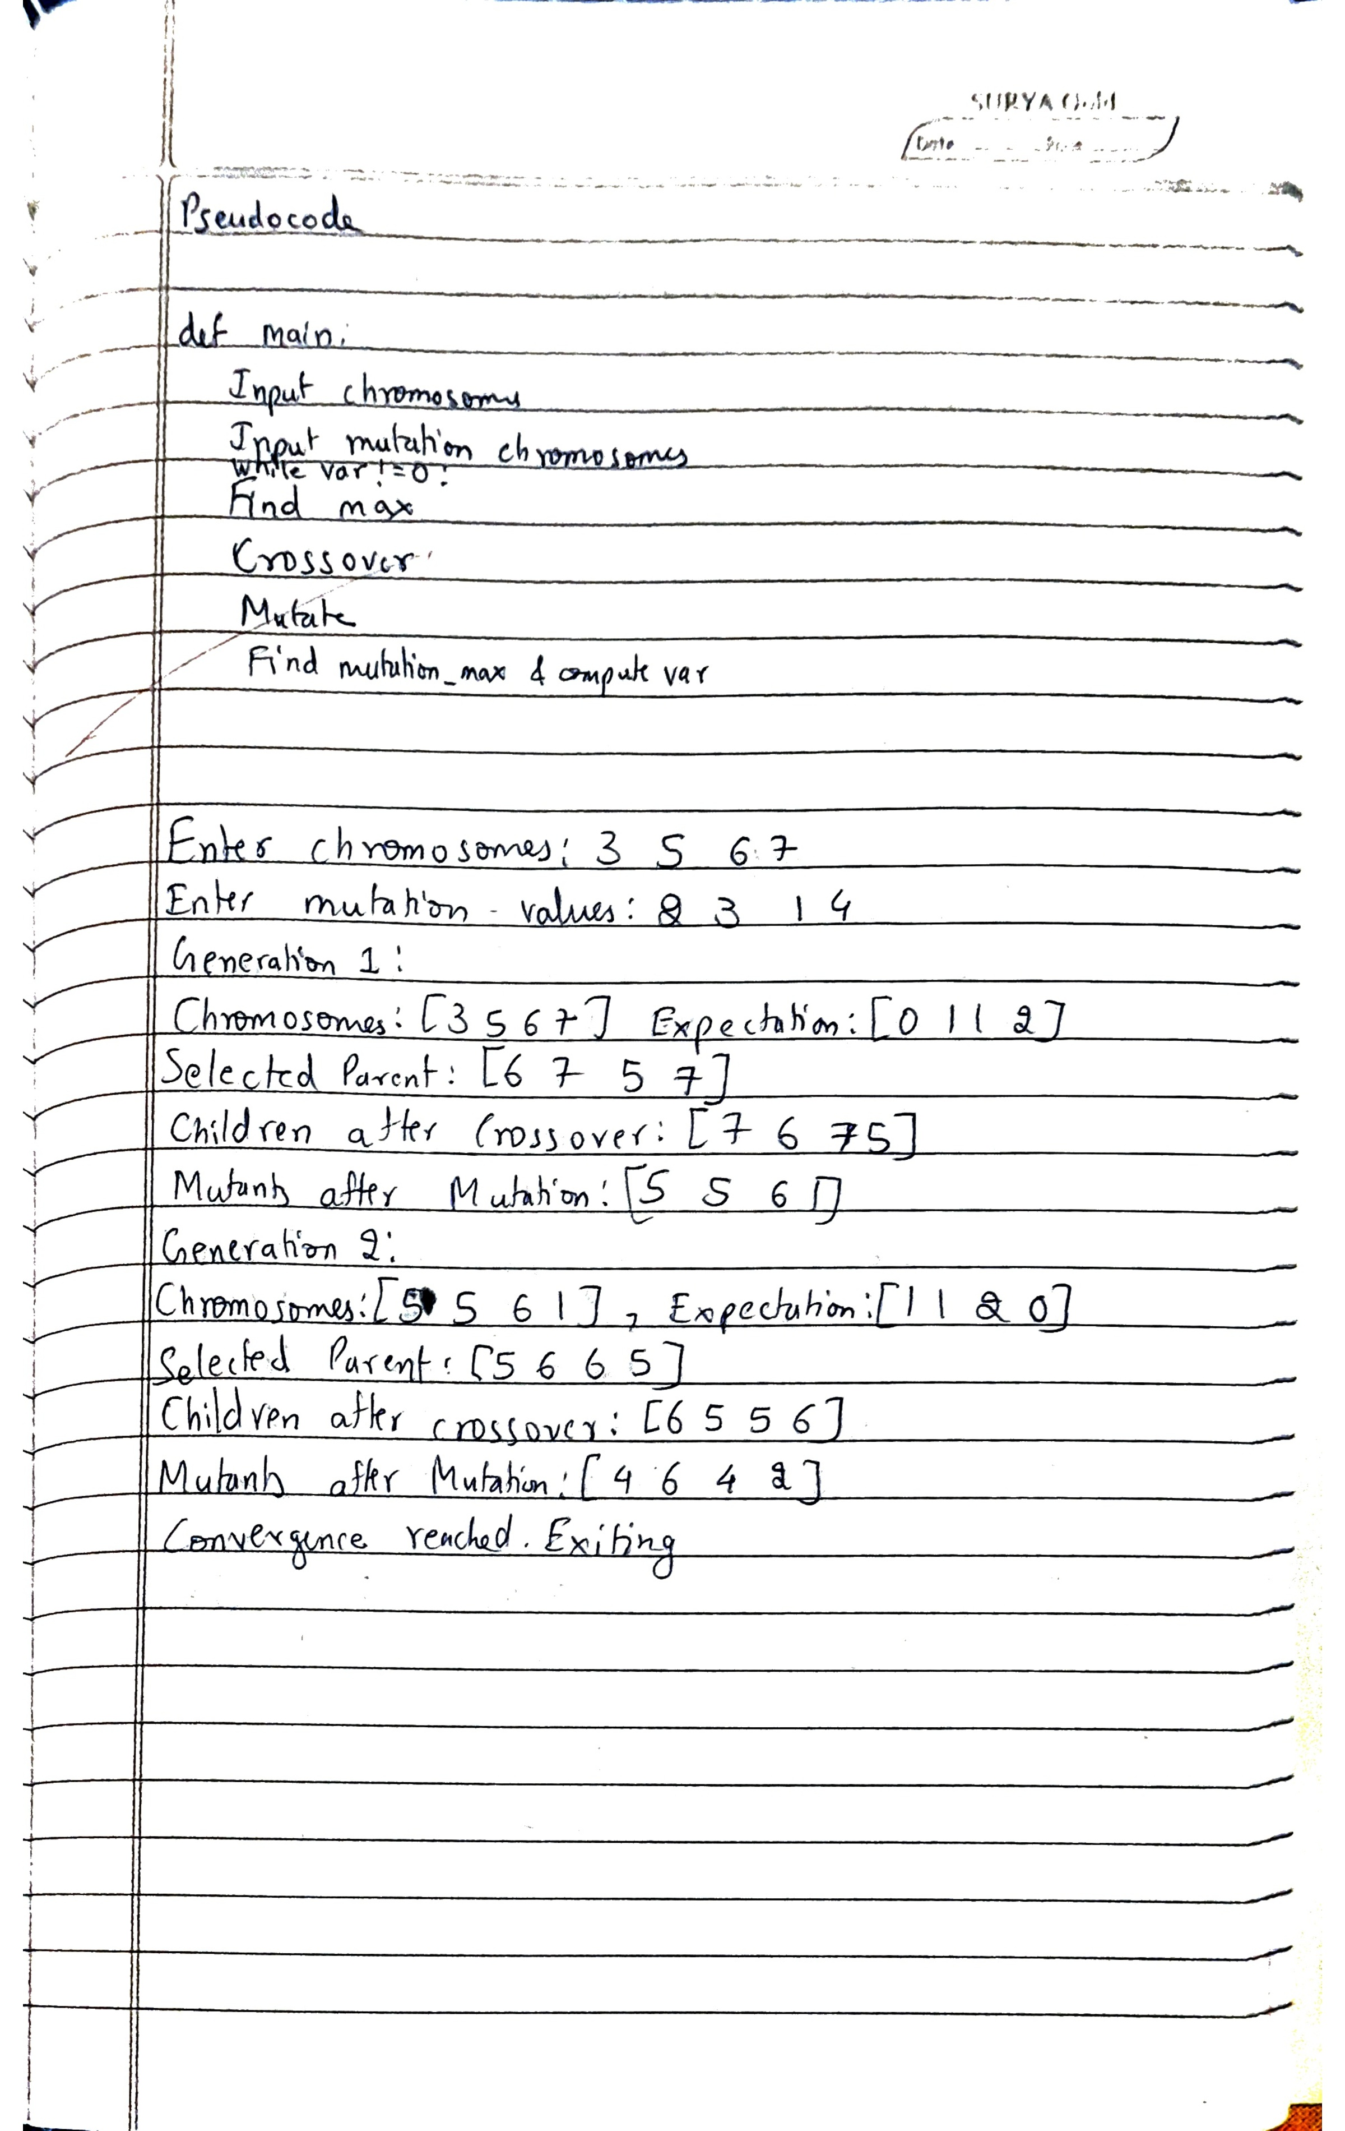
Code:
import random

# Initialize chromosomes and mutation parameters
def init():
global chromosomes
global n
global mutation
ch = input("Enter chromosomes (space separated): ")
chromosomes = [int(x) for x in ch.split()]
n = len(chromosomes)

ch = input("Enter mutation values (space separated): ")
mutation = [int(x) for x in ch.split()]

# Ensure mutation length matches the number of chromosomes
if len(mutation) < n:
# Extend mutation list if too short
mutation.extend([mutation[-1]] * (n - len(mutation)))
elif len(mutation) > n:
mutation = mutation[:n] # Truncate mutation list if too long

# Fitness function: f(x) = x^2 (minimize this)
def fitness(x):
return x**2

# Compute fitness scores and selection probabilities
def compute():
global probs
global expectation
fit_scores = [fitness(chromosome) for chromosome in chromosomes]
max_val = max(fit_scores)
total = sum(fit_scores)
probs = [score / total for score in fit_scores]

# Expectation based on fitness probabilities
expectation = [int(round(prob * n)) for prob in probs]
print("Chromosomes:", chromosomes, end=", ")
print("Expectation:", expectation)
return max_val

# Crossover operation using bitwise masks
def mix(x, y):
mask_high = 24 # 0b11000
mask_low = 7 # 0b00111
c1 = (x & mask_high) | (y & mask_low)
c2 = (y & mask_high) | (x & mask_low)
return c1, c2

# Perform crossover based on selection probabilities
def cross():
global li
li = []

# Selection based on expectation: replicate chromosomes based on their expectation value
for i in range(len(chromosomes)):
li.extend([chromosomes[i]] * expectation[i])

random.shuffle(li)
print("Selected Parents:", li)

temp_li = []
# Crossover: create offspring from selected chromosomes
for i in range(0, len(li) - 1, 2):
c1, c2 = mix(li[i], li[i + 1])
temp_li.extend([c1, c2])

# If odd number of chromosomes, add last chromosome without crossover
if len(li) % 2 != 0:
temp_li.append(li[-1])

li = temp_li
print("Children after Crossover:", li)

# Apply mutation: XOR mutation based on the provided mutation array
def mutate():
global li
global mutation
global chromosomes

for i in range(len(li)):
# Safeguard for mismatch in length
mutation_value = mutation[i % len(mutation)]
li[i] = li[i] ^ mutation_value # XOR operation for mutation

print("Mutants after Mutation:", li)
chromosomes[:] = li # Update chromosomes

# Main algorithm loop
def main():
init() # Initialize chromosomes and mutation values
prev_chromosomes = chromosomes[:] # Store initial chromosomes
generations = 1 # Track number of generations

max_generations = 10 # Set maximum generations to avoid infinite loop
fitness_threshold = 0.01 # Threshold for minimal change in fitness between generations

while generations <= max_generations:
print(f'Generation {generations}:')
compute() # Compute fitness of the current population
cross() # Perform crossover operation
mutate() # Apply mutation operation

# Calculate variance as the difference in the best fitness between generations
# Best chromosome fitness in the current population
current_max_fitness = fitness(max(chromosomes))
# Best chromosome fitness in the previous population
prev_max_fitness = fitness(max(prev_chromosomes))
variance = abs(current_max_fitness - prev_max_fitness)

# If the fitness change is small, we assume convergence
if variance < fitness_threshold:
print("Convergence reached. Exiting.")
break

# Update previous chromosomes and continue
prev_chromosomes = chromosomes[:]
generations += 1

# Check for the maximum generation limit
if generations > max_generations:
print("Max generations reached. Exiting.")
break

if __name__ == '__main__':
main()
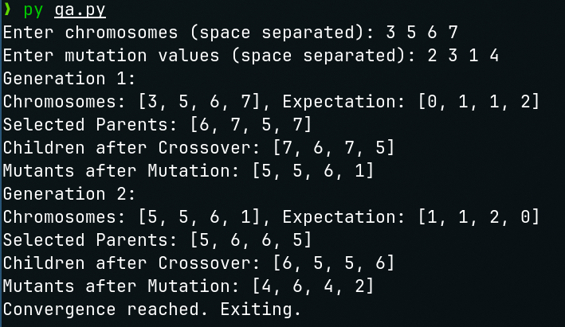

Program 2
Particle Swarm Optimization
Develop a Python program to implement the Particle Swarm Optimization (PSO) algorithm to find the maximum value of the given mathematical function f(x)= - x²+5x+20.

Algorithm:
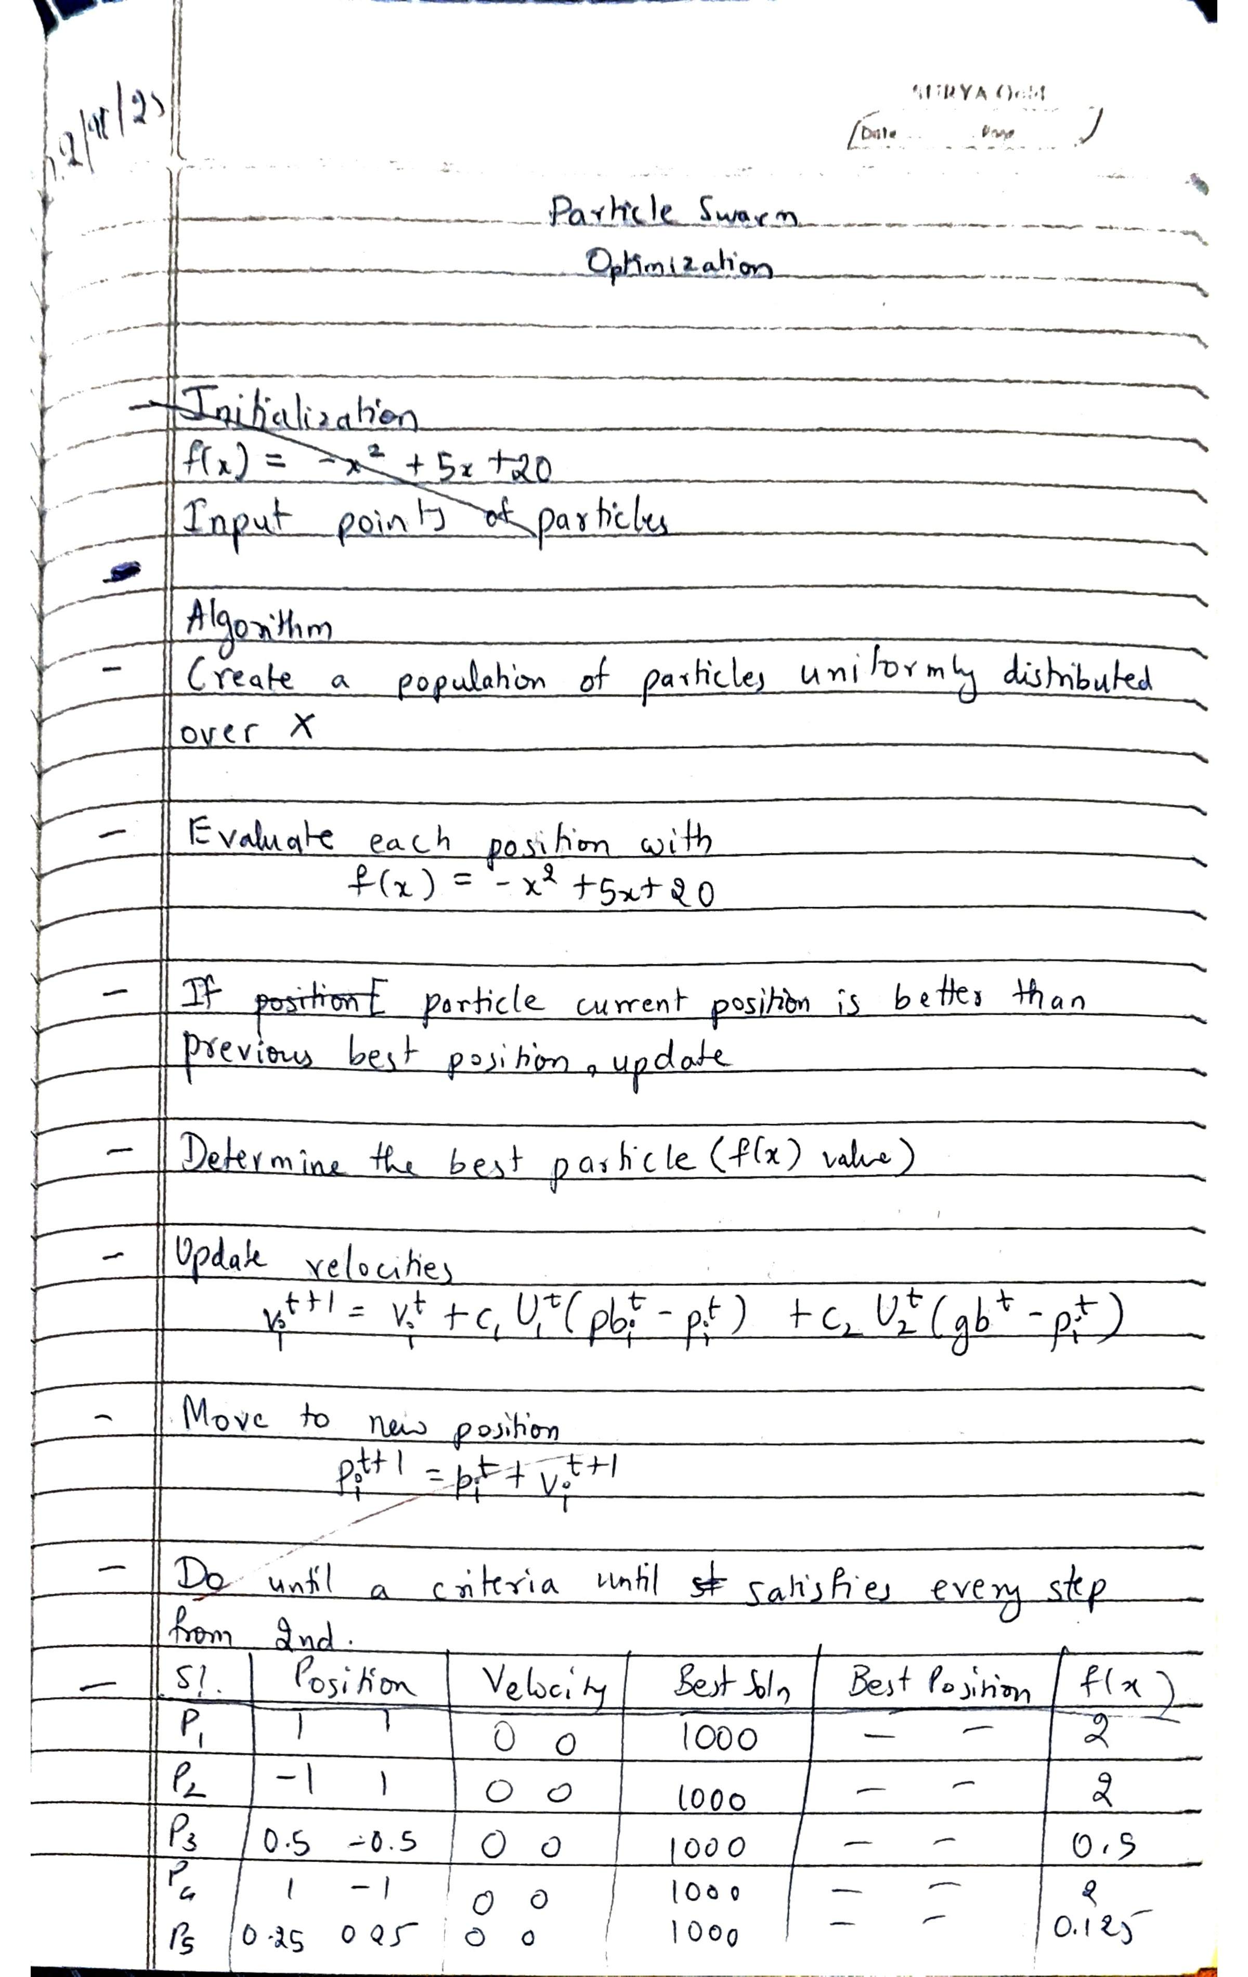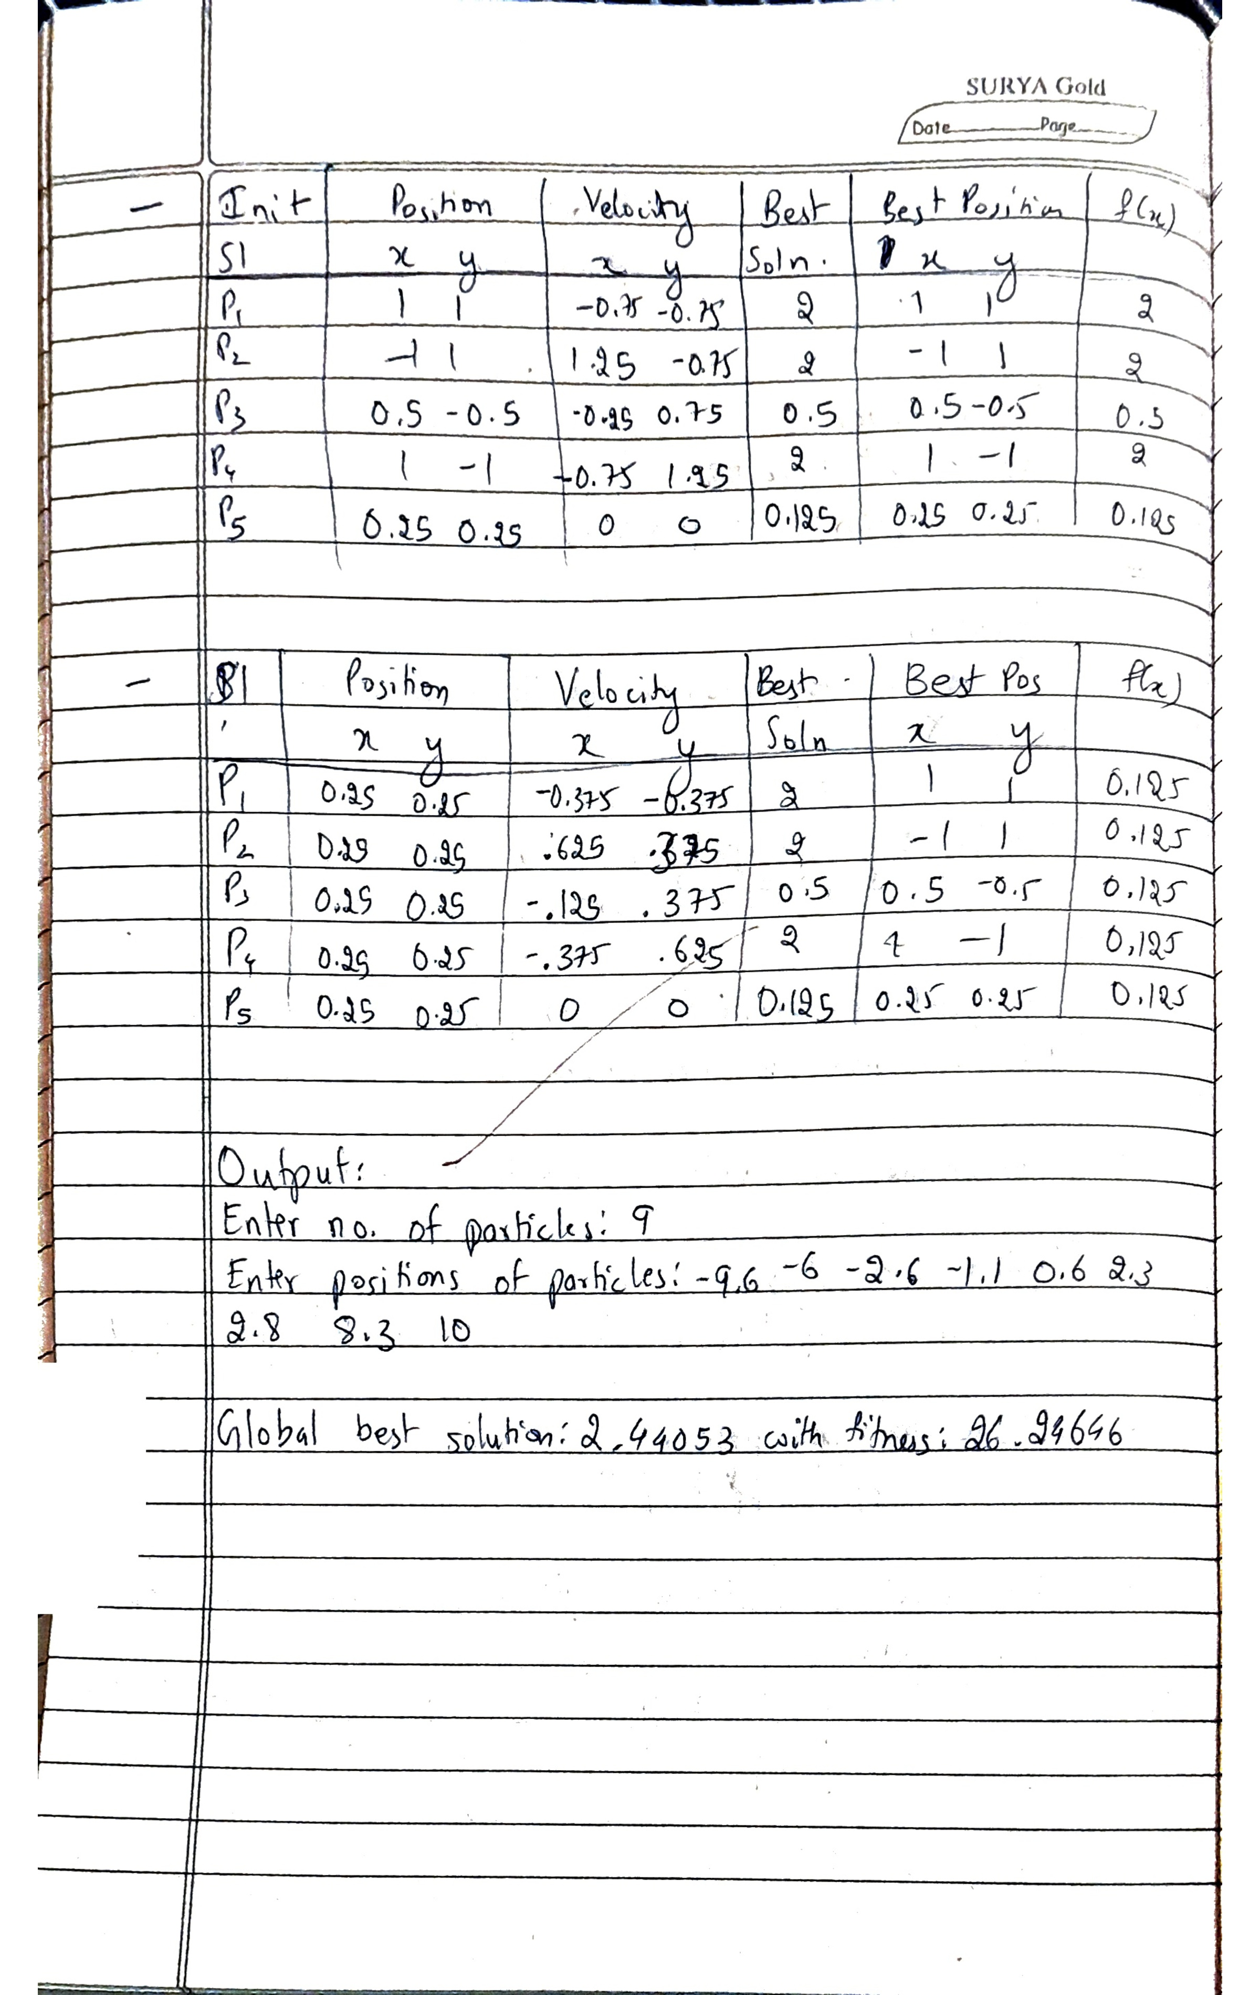
Code:
import random
from math import sqrt

c1, c2 = 1, 1

def fitness(x):
return -x**2 + 5*x + 20

def init():
n = int(input("Enter no. of particles: "))
v = [0 for i in range(n)]
x = list(map(float, input("Enter positions of particles:").split()))
p = x.copy()
fp = [fitness(xi) for xi in x]
return n, v, fp, p, x

def find(n, fp, p):
max_fitness = float('-inf')
pos = -1
for i in range(n):
if fp[i] > max_fitness:
max_fitness = fp[i]
pos = i
return pos

def update(n, v, fp, p, x, max_pos):
r1, r2 = sqrt(random.random()), sqrt(random.random())

for i in range(n):
v[i] = v[i] + c1 * r1 * (p[i] - x[i]) + c2 * r2 * (p[max_pos] - x[i])
x[i] = x[i] + v[i]

for i in range(n):
fp[i] = fitness(x[i])
if fp[i] > fitness(p[i]):
p[i] = x[i]

def print_state(v, fp, p, x):
print(f'''
{x}
{p}
{v}
{fp}
''')

n, v, fp, p, x = init()
print_state(v, fp, p, x)
max_pos = find(n, fp, p)
gbest = p[max_pos]

while True:
update(n, v, fp, p, x, max_pos)
max_pos = find(n, fp, p)
if fitness(gbest) == fitness(p[max_pos]):
break
print_state(v, fp, p, x)
gbest = p[max_pos]

print(f"Global Best Solution: {gbest} with fitness: {fitness(gbest)}")

Program 3
Ant Colony Optimization for TSP
Implement the Ant Colony Optimization (ACO) algorithm to find the shortest possible route that visits a set of cities exactly once and returns to the starting city - Traveling Salesman Problem (TSP).

Algorithm:
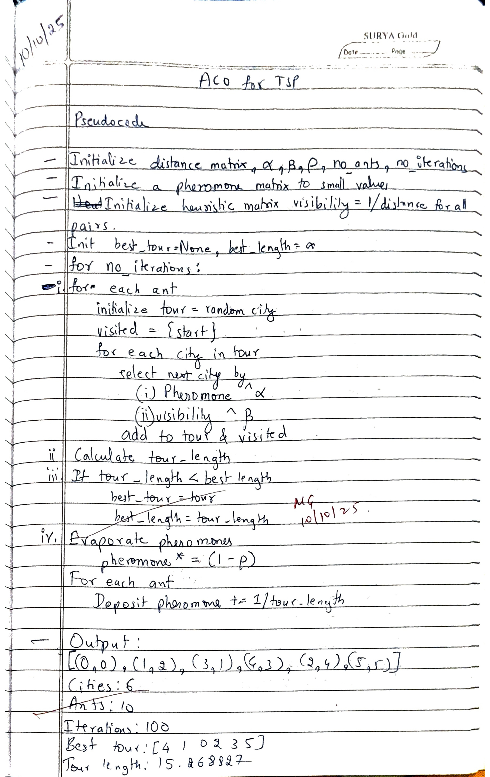
Code:
import random
import numpy as np

# Helper function to calculate distance between two cities
def distance(city1, city2, coordinates):
# Assuming coordinates are (x, y) pairs
x1, y1 = coordinates[city1]
x2, y2 = coordinates[city2]
return np.sqrt((x2 - x1)**2 + (y2 - y1)**2)

# Initialize pheromone matrix and visibility matrix
def initialize_matrices(num_cities, initial_pheromone_value, coordinates):
pheromone = np.full((num_cities, num_cities), initial_pheromone_value)
visibility = np.zeros((num_cities, num_cities))

# Calculate visibility (1 / distance)
for i in range(num_cities):
for j in range(num_cities):
if i != j:
visibility[i][j] = 1 / distance(i, j, coordinates)

return pheromone, visibility

# Calculate probability distribution for the next city
def calculate_probability(current_city, unvisited_cities, pheromone, visibility, alpha, beta):
total = 0
probabilities = {}
for city in unvisited_cities:
pheromone_term = pheromone[current_city][city] ** alpha
visibility_term = visibility[current_city][city] ** beta
probability = pheromone_term * visibility_term
total += probability
probabilities[city] = probability

# Normalize the probabilities
for city in probabilities:
probabilities[city] /= total

return probabilities

# Ant Colony Optimization (ACO) algorithm
def ant_colony_optimization(num_cities, coordinates, num_ants, num_iterations, alpha=1, beta=2, rho=0.5, initial_pheromone_value=0.1):
# Initialize pheromone and visibility matrices
pheromone, visibility = initialize_matrices(num_cities, initial_pheromone_value, coordinates)

best_tour = None
best_length = float('inf')

# Start iterations
for iteration in range(num_iterations):
all_tours = []
all_lengths = []

# Each ant constructs a tour
for ant in range(num_ants):
tour = [random.randint(0, num_cities - 1)] # Start from a random city
visited_cities = {tour[0]} # Keep track of visited cities

while len(tour) < num_cities:
current_city = tour[-1]
unvisited_cities = set(range(num_cities)) - visited_cities
probabilities = calculate_probability(current_city, unvisited_cities, pheromone, visibility, alpha, beta)

# Decide which city to visit next
if random.random() < 0.9: # q0 is 0.9 for greedy selection
next_city = max(probabilities, key=probabilities.get) # Greedy: Choose city with highest probability
else:
next_city = random.choices(list(probabilities.keys()), list(probabilities.values()))[0]

tour.append(next_city)
visited_cities.add(next_city)

# Calculate tour length
tour_length = 0
for i in range(num_cities - 1):
tour_length += distance(tour[i], tour[i + 1], coordinates)
tour_length += distance(tour[-1], tour[0], coordinates) # Return to the starting city

all_tours.append(tour)
all_lengths.append(tour_length)

# Update best solution
if tour_length < best_length:
best_tour = tour
best_length = tour_length

# Evaporate pheromones
pheromone *= (1 - rho)

# Deposit pheromones from each ant
for ant in range(num_ants):
tour = all_tours[ant]
tour_length = all_lengths[ant]
for i in range(num_cities - 1):
pheromone[tour[i]][tour[i + 1]] += 1 / tour_length
pheromone[tour[-1]][tour[0]] += 1 / tour_length # Return to the starting city

return best_tour, best_length

# Example usage
if __name__ == "__main__":
# Example cities coordinates (x, y)
coordinates = [
(0, 0), (1, 2), (3, 1), (4, 3), (2, 4), (5, 5)
]

num_cities = len(coordinates)
num_ants = 10
num_iterations = 100

print(coordinates)
print("Cities:",num_cities)
print("Ants:",num_ants)
print("Iteratios:",num_iterations)
alpha, beta, rho = 1, 2, 0.5
best_tour, best_length = ant_colony_optimization(num_cities, coordinates, num_ants, num_iterations)
print(f"Best tour: {best_tour}")
print(f"Best tour length: {best_length}")

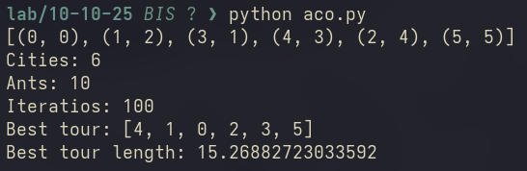
Program 4
Cuckoo Search
Implement a Levy Flight–based stochastic optimization algorithm to solve a 0/1 Knapsack Problem, maximizing total profit while respecting the knapsack capacity constraint.

Algorithm:
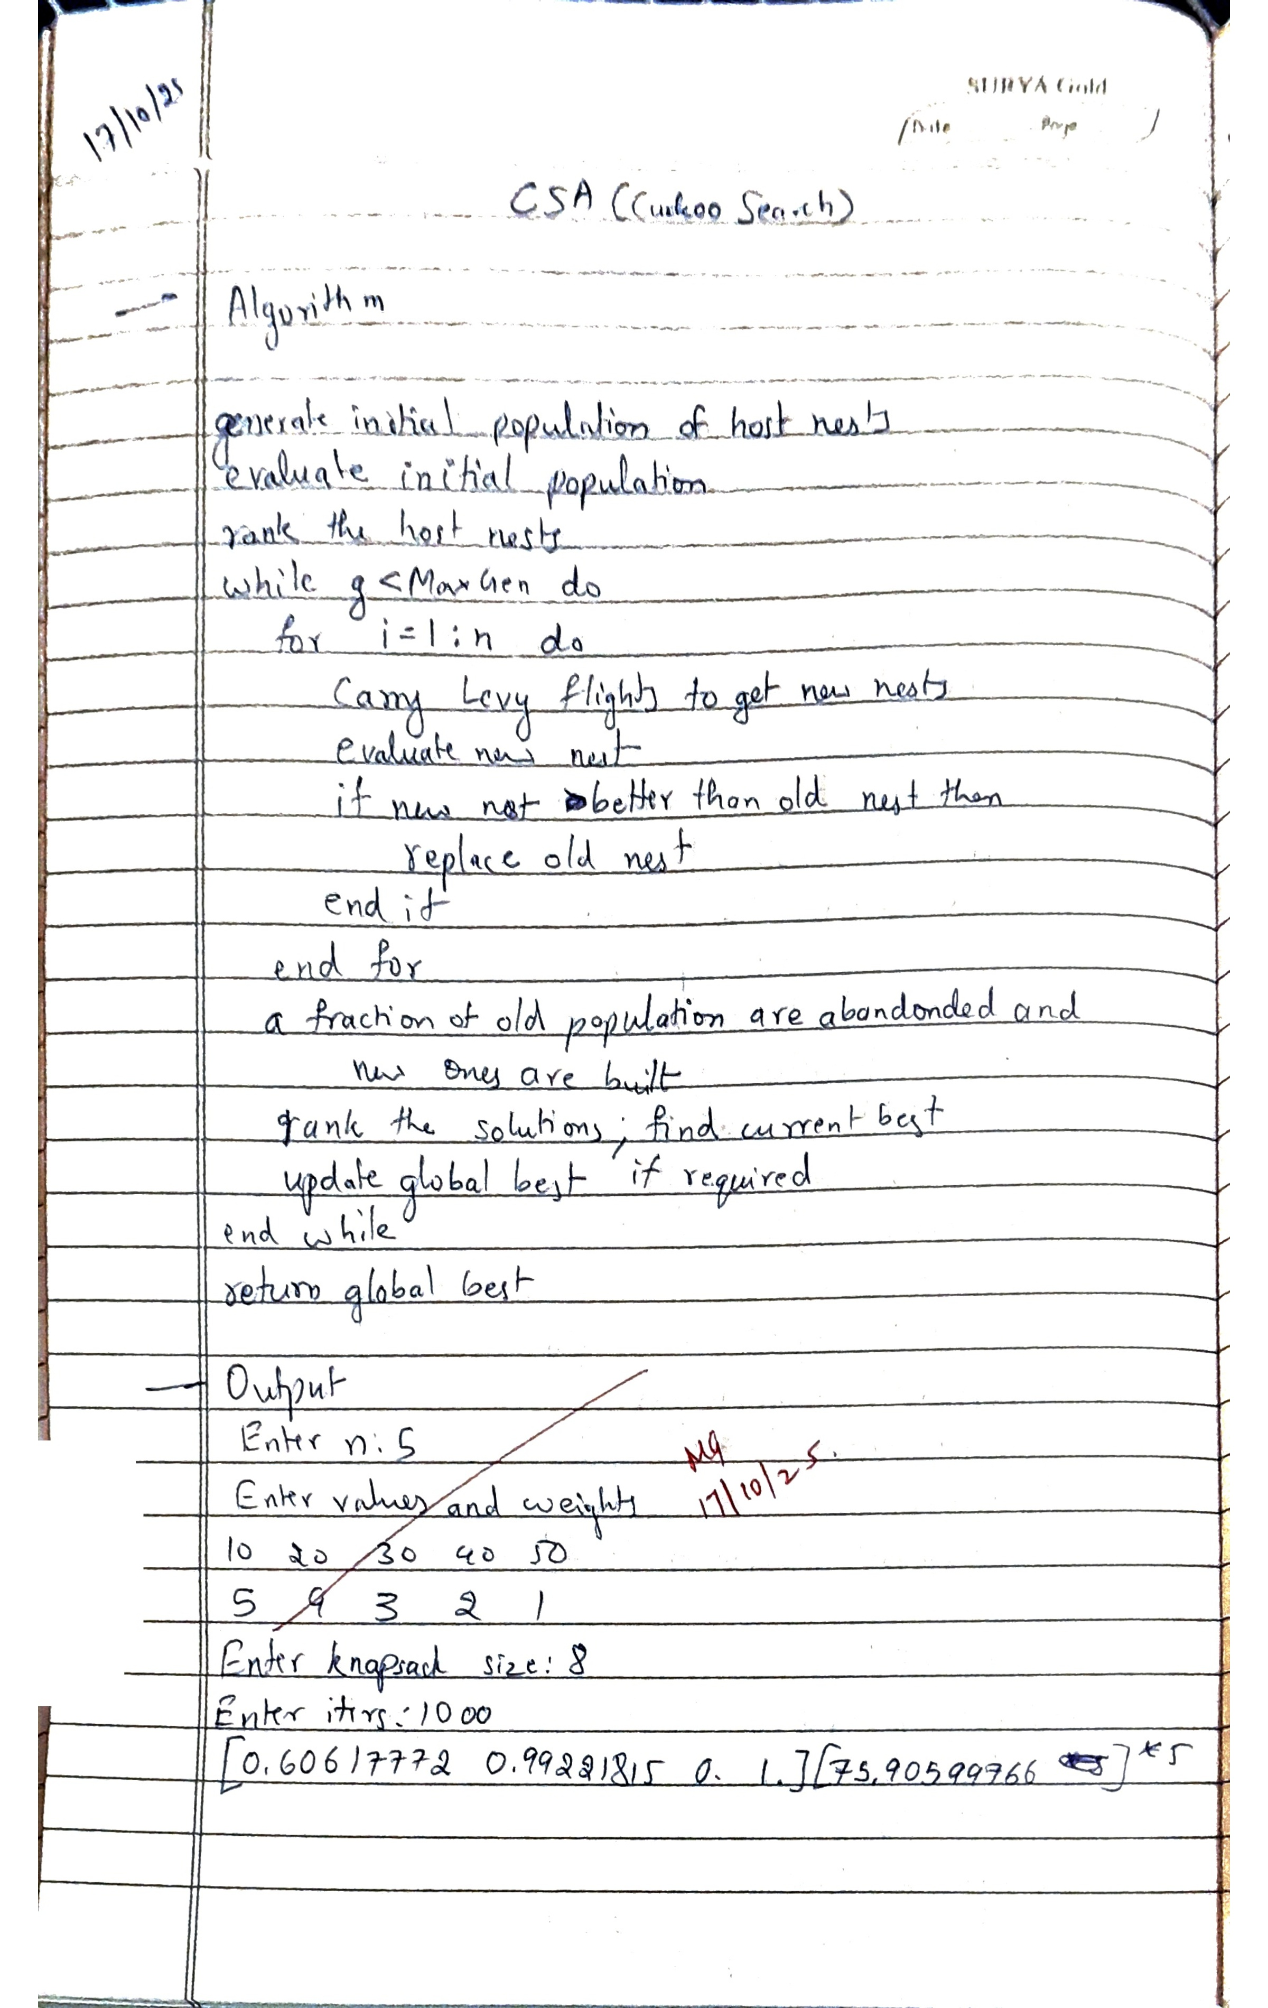
Code:
import numpy as np
from scipy.stats import levy
import random

def init():
n = int(input("Enter n: "))
print("Enter values and weights:")
# Convert input to list of integers
c = np.array(list(map(int, input().split())))
a = np.array(list(map(int, input().split())))
b = int(input("Enter knapsack size: "))
b = np.array([b for _ in range(n)]) # Ensure b is an array of size n
maxt = int(input("Enter iters: "))
return n, c, a, b, random.random(), maxt

def fitness(c, x, a, b, n):
# Perform element-wise operation
# Ensure b is a numpy array to allow element-wise subtraction
temp = np.dot(a, x) - b
rho = max(c[i] / a[i] for i in range(n))
return np.dot(c, x) - (rho * temp) ** 2

def Levy(alpha, n):
step = levy.rvs(size=n)
return alpha * step

n, c, a, b, p, maxt = init()
x = np.random.randint(2, size=n)
best_x = x.copy()
best_fitness = fitness(c, x, a, b, n)
for t in range(maxt):
for i in range(n):
alpha = 0.01
step = Levy(alpha, n)

# Added size=n to ensure vector length matches
new_x = x + np.multiply(step, np.random.choice([1, -1], size=n))
new_x = np.clip(new_x, 0, 1)
new_fitness = fitness(c, new_x, a, b, n)
if sum(new_fitness) > sum(best_fitness):
best_fitness = new_fitness
best_x = new_x.copy()

print(best_x, best_fitness)
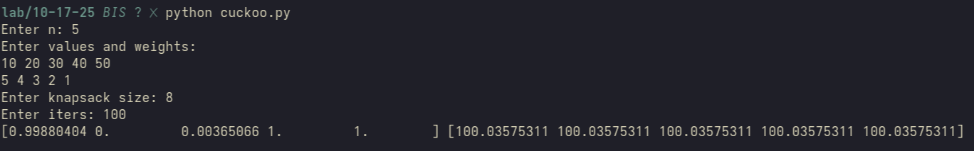
Program 5
Grey Wolf Optimizer
Implement the Grey Wolf Optimizer (GWO) algorithm to find the global minimum of a complex benchmark function — the Rastrigin function — and analyze its convergence behavior.

Algorithm:
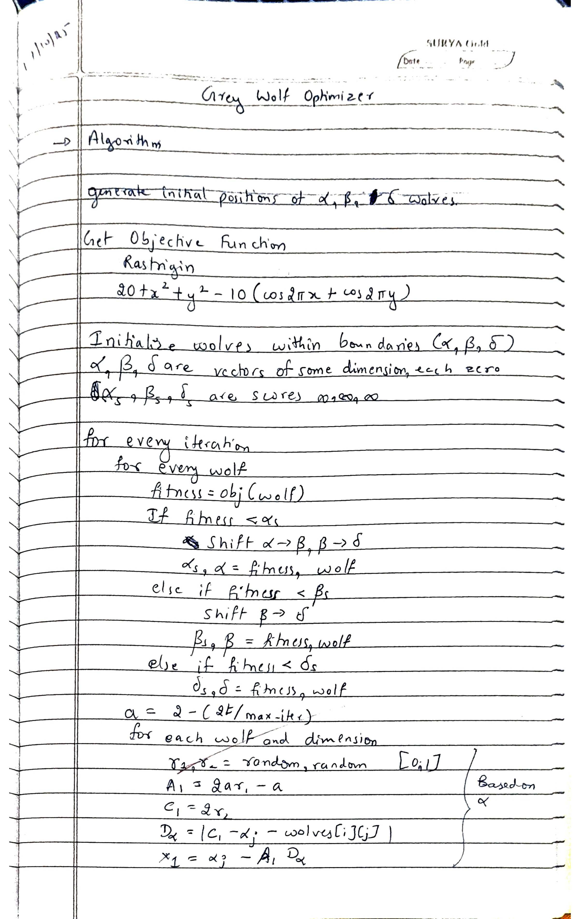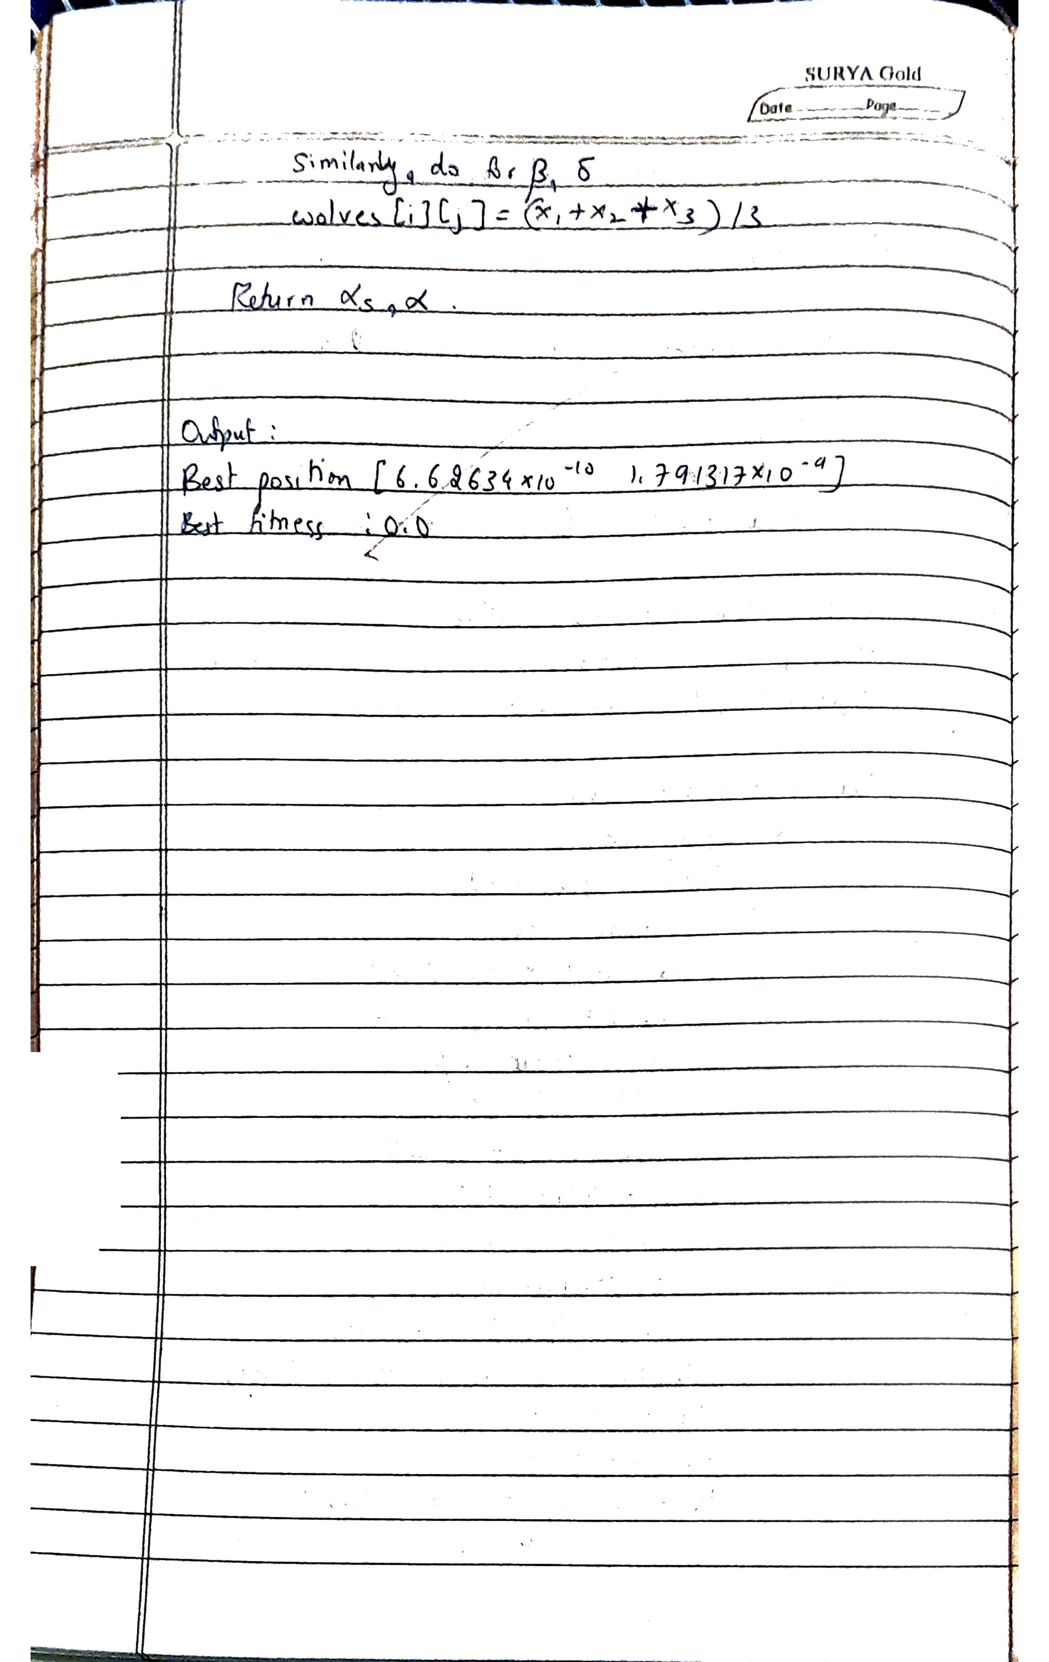
Code:
import numpy as np
import matplotlib.pyplot as plt

# Objective function: Rastrigin function
def rastrigin(position):
x, y = position
return 20 + x**2 + y**2 - 10 * (np.cos(2 * np.pi * x) + np.cos(2 * np.pi * y))

# Grey Wolf Optimizer
def GWO(obj_func, dim, bounds, num_wolves=10, max_iter=100):
# Initialize positions of wolves
wolves = np.random.uniform(bounds[0], bounds[1], (num_wolves, dim))

# Initialize alpha, beta, and delta wolves
alpha, beta, delta = np.zeros(dim), np.zeros(dim), np.zeros(dim)
alpha_score, beta_score, delta_score = np.inf, np.inf, np.inf

convergence_curve = []

for t in range(max_iter):
for i in range(num_wolves):
fitness = obj_func(wolves[i])

# Update alpha, beta, delta
if fitness < alpha_score:
delta_score, delta = beta_score, beta.copy()
beta_score, beta = alpha_score, alpha.copy()
alpha_score, alpha = fitness, wolves[i].copy()
elif fitness < beta_score:
delta_score, delta = beta_score, beta.copy()
beta_score, beta = fitness, wolves[i].copy()
elif fitness < delta_score:
delta_score, delta = fitness, wolves[i].copy()

# Update position of each wolf
a = 2 - 2 * t / max_iter # a decreases linearly from 2 to 0
for i in range(num_wolves):
for j in range(dim):
r1, r2 = np.random.rand(), np.random.rand()
A1, C1 = 2 * a * r1 - a, 2 * r2
D_alpha = abs(C1 * alpha[j] - wolves[i, j])
X1 = alpha[j] - A1 * D_alpha

r1, r2 = np.random.rand(), np.random.rand()
A2, C2 = 2 * a * r1 - a, 2 * r2
D_beta = abs(C2 * beta[j] - wolves[i, j])
X2 = beta[j] - A2 * D_beta

r1, r2 = np.random.rand(), np.random.rand()
A3, C3 = 2 * a * r1 - a, 2 * r2
D_delta = abs(C3 * delta[j] - wolves[i, j])
X3 = delta[j] - A3 * D_delta

wolves[i, j] = (X1 + X2 + X3) / 3

# Keep wolves within bounds
wolves = np.clip(wolves, bounds[0], bounds[1])

convergence_curve.append(alpha_score)

return alpha, alpha_score, convergence_curve

# Parameters
dim = 2
bounds = [-5.12, 5.12]
num_wolves = 20
max_iter = 100

# Run GWO
best_position, best_score, convergence = GWO(
rastrigin, dim, bounds, num_wolves, max_iter)

# Results
print("Best position found:", best_position)
print("Best fitness value:", best_score)

# Plot convergence curve
plt.plot(convergence)
plt.title("Convergence Curve of Grey Wolf Optimizer")
plt.xlabel("Iterations")
plt.ylabel("Best Fitness Value")
plt.grid(True)
plt.show()

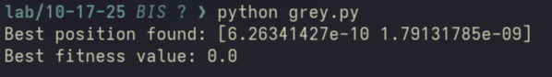

Program 6
Parallel Cell Automaton
Develop and analyze a two-dimensional cellular automaton (CA) based on a Rule 30–inspired update rule, to study emergent complex behavior arising from simple binary local interactions.

Algorithm:
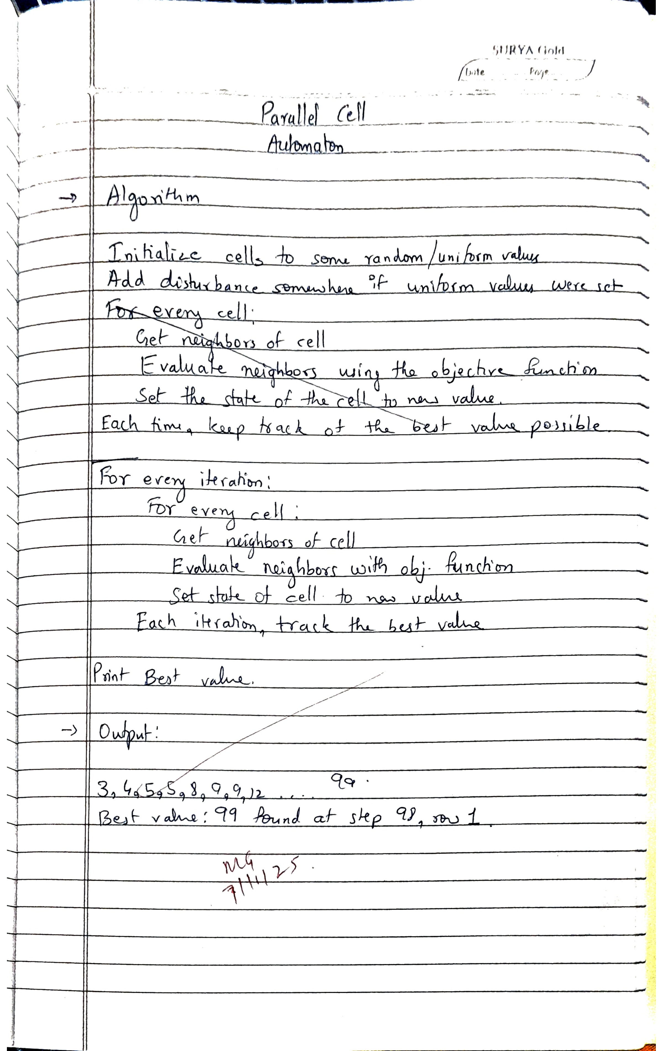
Code:
import numpy as np
import matplotlib.pyplot as plt

def objective_function(top, left, center, right, bottom):
# Rule 30 logic, combining neighbors in the 2D grid
return top ^ (left or right or bottom or center)

# Initialize the 2D grid (binary states)
size_x = 101 # Number of columns
size_y = 101 # Number of rows
steps = 100 # Number of iterations
grid = np.zeros((steps, size_y, size_x), dtype=int)
# grid = np.random.randint(low=10, size=(steps, size_y, size_x), dtype=int)
# Set the initial state (a single 1 in the center)
grid[0, size_y // 2, size_x // 2] = 1

# Variable to track the best value and the corresponding step
best_value = 0
best_step = 0
best_row = 0

# Iterate to evolve the 2D grid
for t in range(1, steps):
for i in range(1, size_x - 1): # Update columns (avoiding boundaries)
for j in range(1, size_y - 1): # Update rows (avoiding boundaries)
# Get the neighboring states (top, left, center, right, bottom)
top = grid[t-1, j-1, i]
left = grid[t-1, j, i-1]
center = grid[t-1, j, i]
right = grid[t-1, j, i+1]
bottom = grid[t-1, j+1, i]
grid[t, j, i] = objective_function(
top, left, center, right, bottom)

# Track the best value: sum of '1's in the grid at this step
row_sums = np.sum(grid[t], axis=1) # Sum of each row
# Best sum of '1's in any row for this step
current_best = np.max(row_sums)
print(f"{current_best}", end=",")
if current_best > best_value:
best_value = current_best
best_step = t
best_row = np.argmax(row_sums) # Row that produced the best value

# Plot the result
plt.imshow(np.sum(grid, axis=0), cmap='binary', interpolation='nearest')
plt.title(
f'2D Cellular Automaton (Rule 30-like)\nBest value: {best_value} at step {best_step}, row {best_row}')
plt.show()

# Print the best value information
print(f"\nBest value: {best_value} found at step {best_step}, row {best_row}")

Program 7
Gene Expression Algorithm
Design and implement a Gene Expression Programming (GEP) algorithm to evolve mathematical expressions that approximate or exactly reproduce a given target function. The program should automatically discover the functional relationship between input x and output f(x) through genetic operations such as mutation, crossover, and selection.

Algorithm:
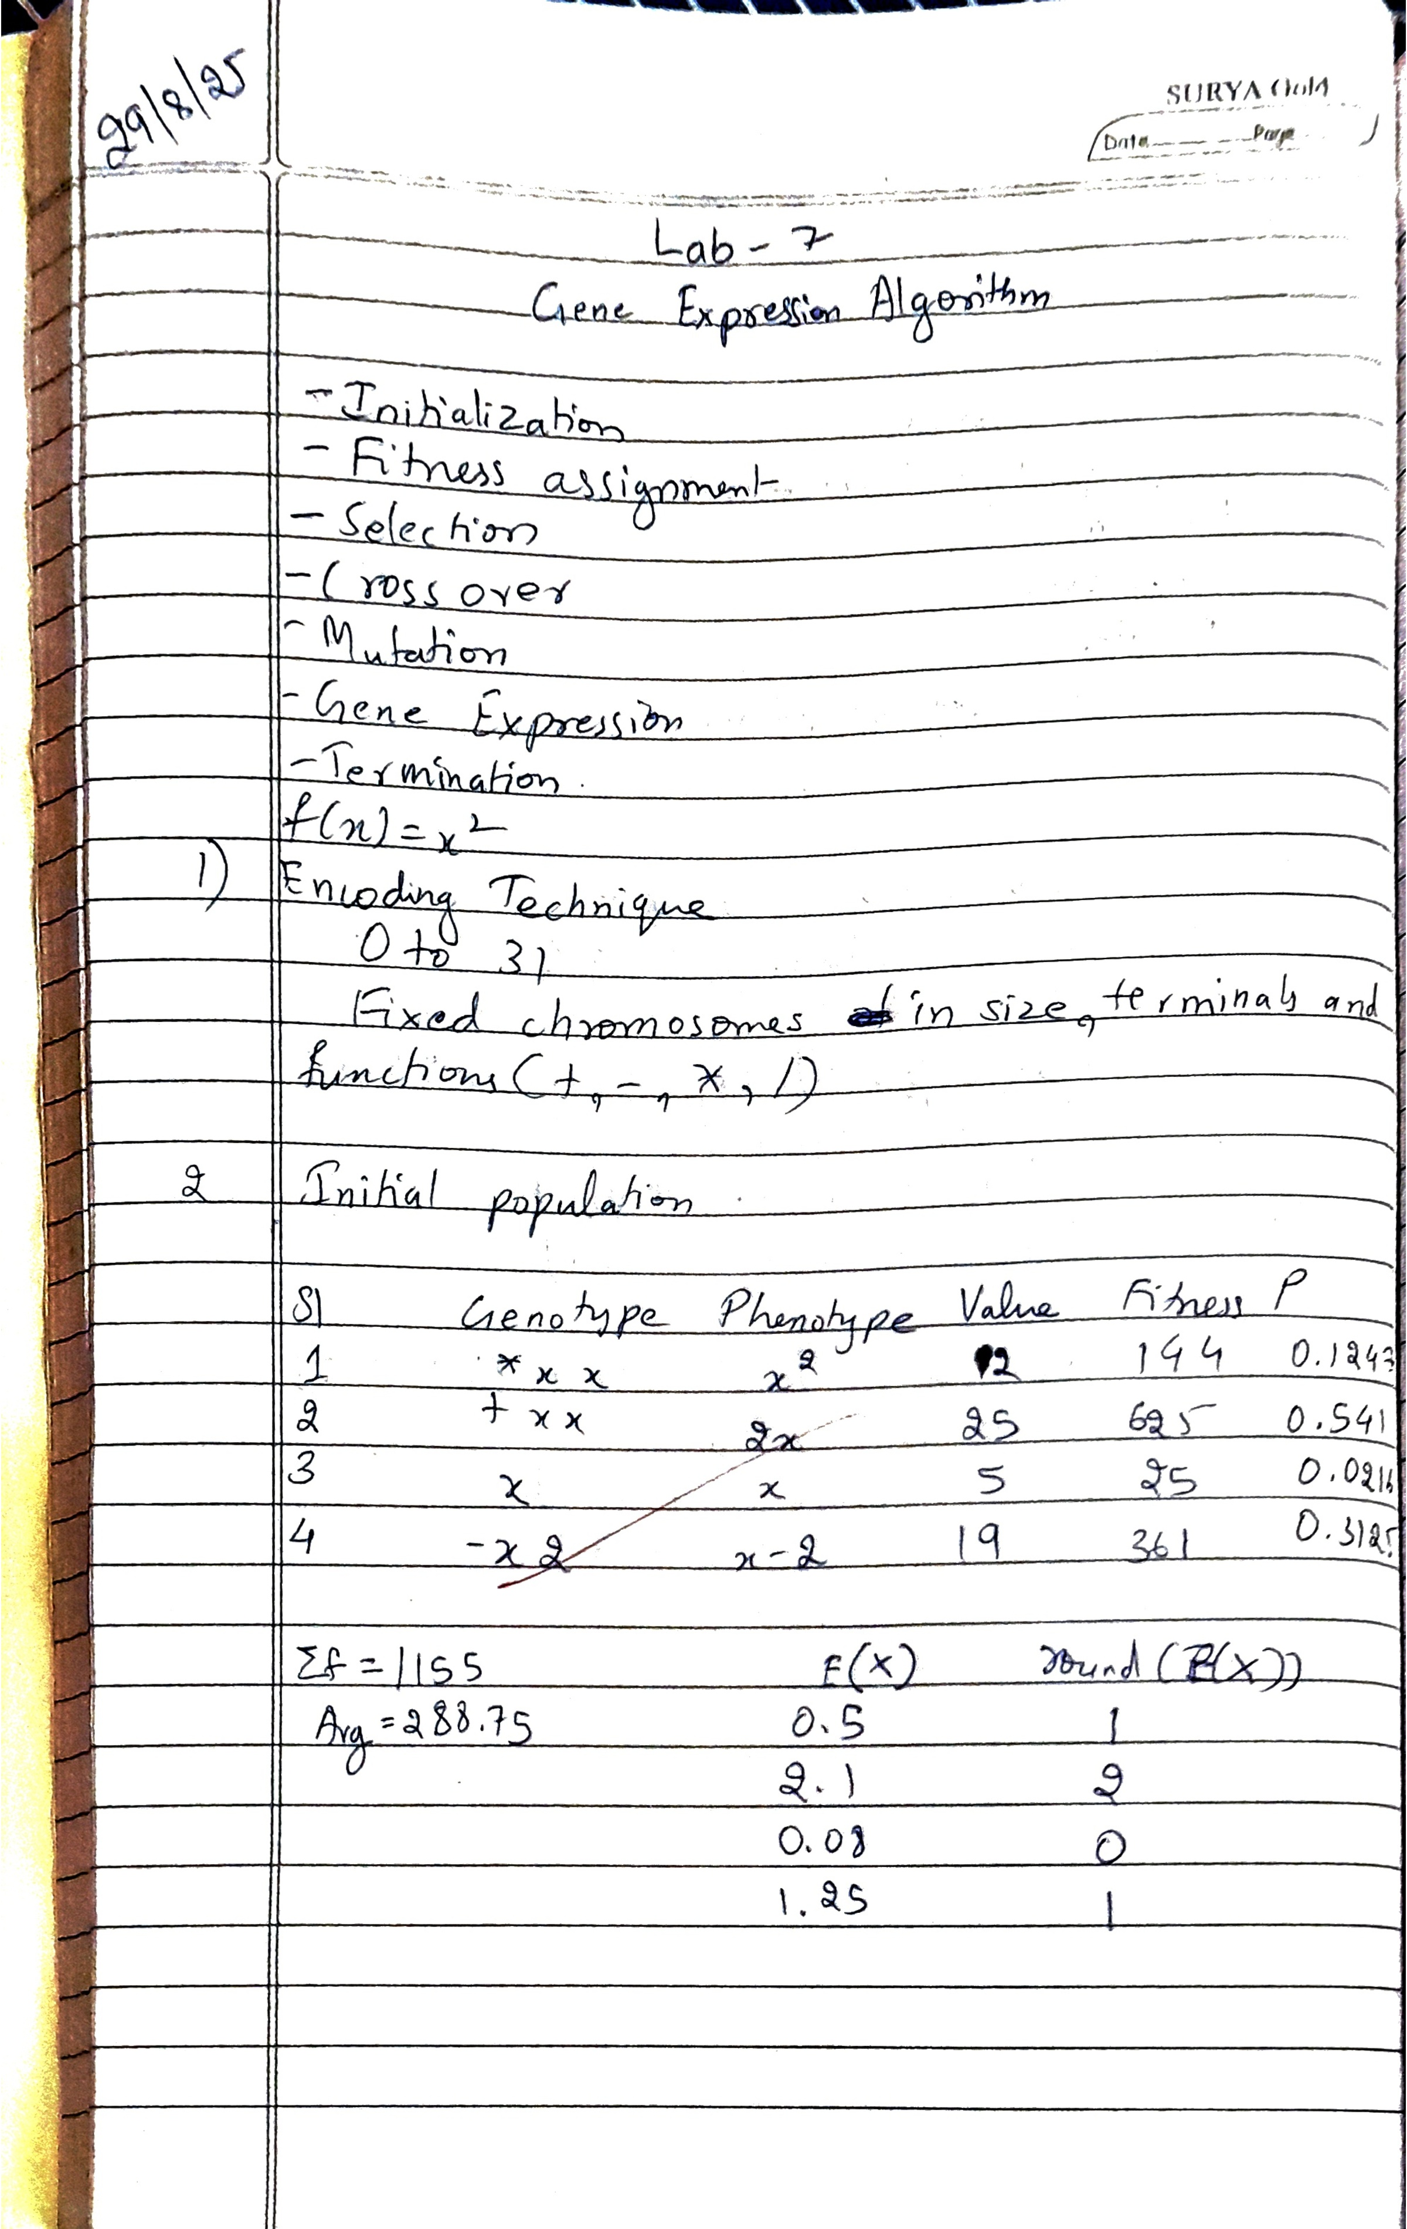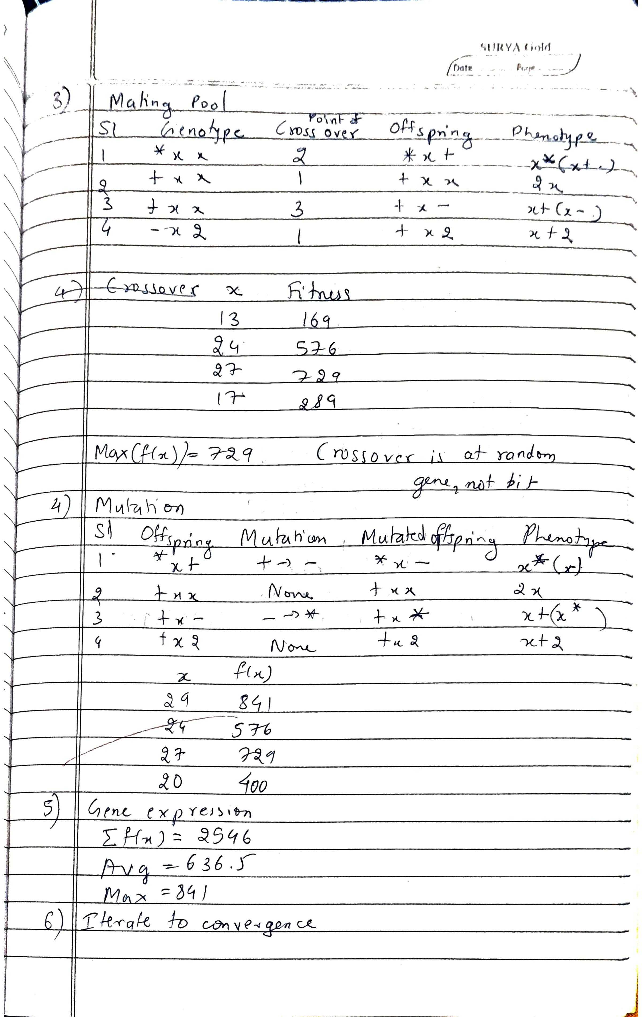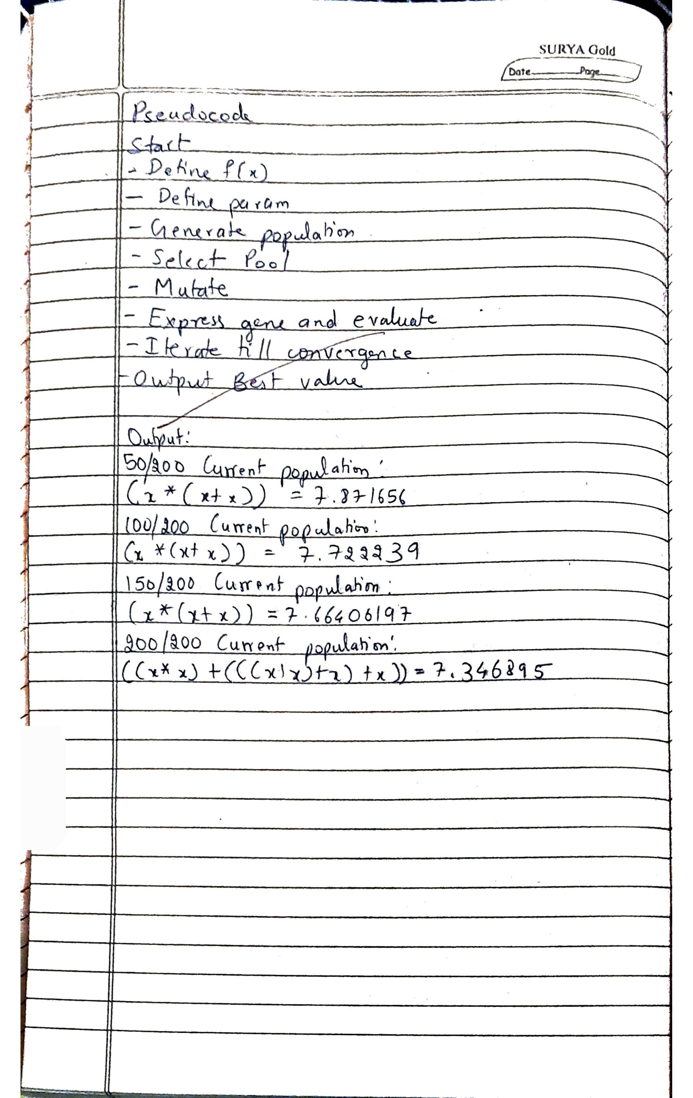
Code:
import numpy as np

def fitness(x):
# return x ** 2
# return (x + x * x) / (x ** 3)
return (x * x) + (x * x) - (x + x)

class GEP(object):
def __init__(self, grammar, bounds, len_head, iterations, pop_size, prob_crossover, num_trials):
self.grammar = grammar
self.bounds = bounds
self.len_head = len_head
self.len_tail = len_head * (len(grammar['TERM'])) + 1
self.iterations = iterations
self.pop_size = pop_size
self.prob_crossover = prob_crossover
self.num_trials = num_trials
self.population = [Individual(self.random_genome())
for _ in range(self.pop_size)]
self.best = sorted(self.population, key=lambda x: x.fitness)[0]

def binary_tournament(self):
a, b = np.random.choice(self.population, 2)
return a if a.fitness < b.fitness else b

def point_mutation(self, genome):
rate = 1.0 / len(genome)
child = list()
for i in range(len(genome)):
bit = genome[i]
if np.random.random() < rate:
if i < self.len_head:
selection = self.grammar['FUNC'] if np.random.random(
) < 0.5 else self.grammar['TERM']
bit = selection[np.random.randint(0, len(selection))]
else:
bit = self.grammar['TERM'][np.random.randint(
0, len(self.grammar['TERM']))]
child.append(bit)
return ''.join(child)

def crossover(self, parent1, parent2):
if np.random.random() < self.prob_crossover:
return ''.join([a if np.random.random() < 0.5 else b for a, b in zip(parent1, parent2)])
else:
return parent1

def reproduce(self, selected):
children = list()
for a, b in zip(selected[::2], selected[1::2]):
children.append(Individual(self.point_mutation(
self.crossover(a.genome, b.genome))))
return children

def random_genome(self):
s = list()
for _ in range(self.len_head):
selection = self.grammar['FUNC'] if np.random.random(
) < 0.5 else self.grammar['TERM']
s.append(selection[np.random.randint(0, len(selection))])
for _ in range(self.len_tail):
s.append(self.grammar['TERM'][np.random.randint(
0, len(self.grammar['TERM']))])
return ''.join(s)

@staticmethod
def cost(program):
errors = 0.0
if FROM_TABLE:
for x, y in TABLE:
expression = program.replace('x', str(x))
try:
score = eval(expression)
except ZeroDivisionError:
score = float('inf')
errors += abs(score - y)
if np.isnan(errors):
errors = float('inf')
return errors / len(TABLE)
else:
for _ in range(NUM_TRIALS):
x = BOUNDS[0] + ((BOUNDS[1] - BOUNDS[0]) * np.random.random())
expression = program.replace('x', str(x))
try:
score = eval(expression)
except ZeroDivisionError:
score = float('inf')
errors += np.abs(score - fitness(x))
return errors / NUM_TRIALS

@staticmethod
def mapping(genome):
off = 0
queue = list()
root = {'node': genome[off]}
off += 1
queue.append(root)
while len(queue) > 0:
current = queue.pop(0)
if current['node'] in GRAMMAR['FUNC']:
current['left'] = {'node': genome[off]}
off += 1
queue.append(current['left'])
current['right'] = {'node': genome[off]}
off += 1
queue.append(current['right'])
return root

@staticmethod
def tree_to_string(exp):
if 'left' not in exp or 'right' not in exp:
return exp['node']
left = GEP.tree_to_string(exp['left'])
right = GEP.tree_to_string(exp['right'])
if exp['node'] in ['+', '-', '*', '/']:
return '({0} {1} {2})'.format(left, exp['node'], right)
else:
func = {
'P': 'np.power',
}.get(exp['node'], None)
return '({0}({1}, {2}))'.format(func, left, right)

def run(self):
for gen in range(1, self.iterations + 1):
selected = [self.binary_tournament() for _ in range(self.pop_size)]
children = self.reproduce(selected)
children = list(sorted(children, key=lambda x: x.fitness))
self.best = children[0] if children[0].fitness <= self.best.fitness else self.best
self.population = sorted(
(children + self.population), key=lambda x: x.fitness)[:self.pop_size]
if gen % 50 == 0:
print('{0}/{1} Current population:'.format(gen, self.iterations))
print(self.best)
if self.best.fitness == 0.0:
print('{0}/{1} Current population:'.format(gen, self.iterations))
print(self.best)
break
return self.best

class Individual(object):
def __init__(self, genome):
self.genome = genome
self.expression = GEP.mapping(genome)
self.program = GEP.tree_to_string(self.expression)
self.fitness = GEP.cost(self.program)

def __str__(self):
return '{0} = {1}'.format(self.program, self.fitness)

GRAMMAR = {'FUNC': ['+', '-', '*', '/'], 'TERM': ['x']}
BOUNDS = [1.0, 10.0]
TABLE = [
[0, 0],
[1, 1],
[2, 4],
[3, 9],
[4, 16],
[5, 25],
[6, 36],
[7, 49],
[8, 64],
[9, 81],
[10, 100]
]
NUM_TRIALS = 30
FROM_TABLE = False
LEN_HEAD = 30
ITERATIONS = 200
POP_SIZE = 100
PROB_CROSS = 0.85

def main():
gep = GEP(GRAMMAR, BOUNDS, LEN_HEAD, ITERATIONS,
POP_SIZE, PROB_CROSS, NUM_TRIALS)
gep.run()

if __name__ == '__main__':
main()

